W7-S2 PRACTICE
FROM IDEA TO MOCKUP

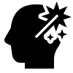 At the end of this practice, you should be able to…
- Define Your Website's Personality among the 7 personalities types
- Plan Design Elements: fonts, colors, layouts, border radius, shadows, etc.
- Create Figma Mockup: Design a detailed website prototype
- Justify Your Choices: Explain how your design supports your goals

 Resources
You will need to read and use the following resources to perform this Web Design project

THEORY OF WEB DESIGN
- CADT Course slides
- All Web Rules and Guidelines
- The 7 Websites Personalities

TYPOGRAPHY
- https://fonts.google.com

COLORS
- https://yeun.github.io/open-color
- https://coolors.co/palettes/trending
- https://paletton.com
- https://flatuicolors.com
- https://coolors.co/contrast-checker

IMAGES
- https://unsplash.com
- https://squoosh.app

ICONS
- https://fonts.google.com/icon
- https://phosphoricons.com
- https://icons8.com/icons

DESIGN INSPIRATIONS
- https://land-book.com

PART 1 – Identify your business & your website personality

The first part of this project is to identify
- Which business to you want to build a website for
- Which website personality you want to apply

THE BUSINESS
Your business Type | Select your website type of business  - Education  - Non-Profit and Community Services  - Sports and Fitness  - Agriculture and Environment  - Art and Design  - Travel and Hospitality  - Finance and Insurance  - Healthcare and Pharmaceuticals  - Manufacturing and Production  - Media and Entertainment  - Technology and Software  - Food and Beverage  - Services  - E-commerce  - Other (specify)
Your business Description | Recommend places to help you decide where to go or what to do when ure in phnom penh

YOUR WEBSITE PERSONALITY
Website Personality | Select your website personality (check this link for details)  - Serious/Elegant  - Minimalist/Simple  - Plain/Neutral  - Bold/Confident  - Calm/Peaceful  - Startup/Upbeat  - Playful/Fun

PART 2 – Analyze other designs and plan your layout

The second part of this project is to:
- Check for inspiration on website design inspiration galleries
- Draw on paper your first ideas…
- Identify your website layout approach

INSPIRATIONS
Your inspiration references | List some websites that inspired your design (example this one)  Tripadvisor, Google Travel, Booking.com, Expedia

THE FIRST IDEAS
Your first mock up | Copy here your paper ideas for your first design  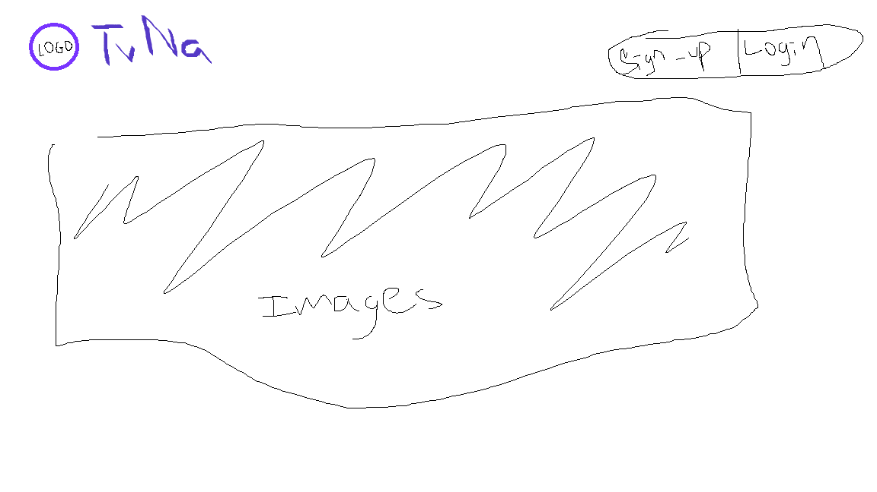
How do you define your layout approach ? | Select your layout among the list - or write a description  - Single-Column Layout  - Grid based layout  - Row of Cards  - Masonry Layout  - Hero Section Layout  - Magazine Layout  - Fullscreen Layout  - Sidebar Layout  - Split-Screen Layout  - Z-Pattern Layout  - Other (describe your layout)

PART 3 – Specify the website design ingredients

Now you need to specify the fonts, colors, icons pack, shadows you want to use for your design
- Make sure you understand the 75 web design ingredients

- Look up for
  - Fonts
      - https://fonts.google.com
  - Colors
      - https://yeun.github.io/open-color
      - https://coolors.co/palettes/trending
      - https://paletton.com
      - https://flatuicolors.com
  - Icons
      - https://fonts.google.com/icon
      - https://phosphoricons.com
      - https://icons8.com/icons
  - Image
      - https://unsplash.com

THE DESIGN SPECIFICATION
Typography | Which fonts will you use?  - Headlines 1 Font name: Roboto  - Headlines 2 Font name: Inner  - Paragraph Font name: M3  - Etc.
Colors | Which colors will you use?  - Your main color #ffffff & #080069  - Your gray color #3f3f3f & #000000  - Accent color #741eff  - Tints and shades “versions”  - Etc.
Icons  (If any) | Are you using icon?  Yes  Which Icon pack will you use? (URL)  We made our own icons and elements  What are the goals of icons in your design?  ex: display logo, display features and action, visual assistance to text to sign-in/login etc.
Shadows  (If any) | Are you using shadows?  Yes  What are the goals of shadows in your design?  ex: to add visual assistance to text and help display the buttons better.
Border Radius | Are you using border radius?  Yes  Where border radius is applied?  ex: on images, buttons, and cards.

PART 4 – Detailed website prototype

Now it s time to present your detailed design, which will be reviewed by other students and lecturer next week

- Either copy the mock up here or provide a FIGMA link to your work
figma_link

